This is a screenshot of the ACT website that the Registrar will NOT take, because it does not show my full name.  BUT…..

(see below)

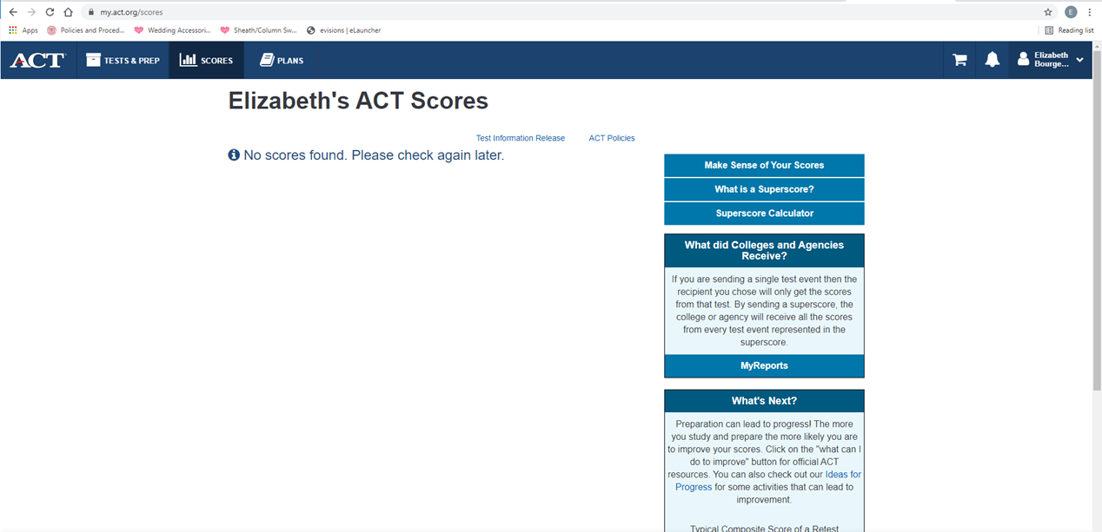

If you pull down the drop down next to my name it reveals my entire name and email address.  I can then take the screenshot that will be recognized.



