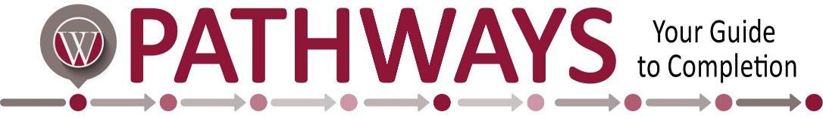

|  |  |  |  |
| --- | --- | --- | --- |
| **Business Management & Supervision**  **Short Certificate** | | | |
|  | Course # | Course Name | Credit Hours |
| Semester 1 | BUS 186 | Elements of Supervision | 3 |
|  | BUS 215 | Business Communications | 3 |
|  | BUS 241 | Principles of Accounting I | 3 |
|  | BUS 275 | Principles of Management | 3 |
|  | BUS 279 | Small Business Management | 3 |
|  | CIS 146 | Computer Applications | 3 |
|  |  |  | **Program Total:**  **18** |

**NOTE:** This Guided Pathway contains all the coursework required for degree/certificate completion. However, courses may be offered or taken in other semesters as long as prerequisites are met. Courses may be available days, nights, hybrid, and online.