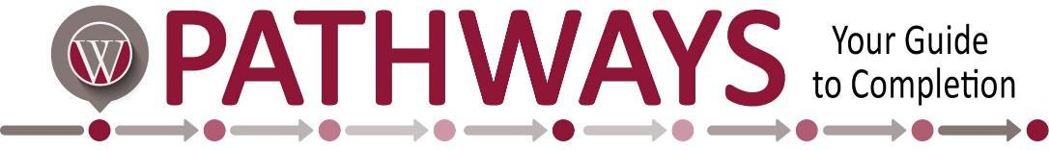

|  |  |  |  |
| --- | --- | --- | --- |
| **Office Administration**  **Short Term Certificate** | | | |
|  | Course # | Course Name | Credit Hours |
| Semester 1 | BUS 215 | Business Communications | 3 |
|  | CIS 146 | Microcomputer Applications | 3 |
|  | OAD 103 | Intermediate Keyboarding | 3 |
|  | OAD 125 | Word Processing | 3 |
|  | OAD 138 | Records/Information Management | 3 |
|  | OAD 217 | Office Management OR | 3 |
|  | OAD 104 | Advanced Keyboarding | 3 |
|  |  |  | **Program Total:**  **18** |

**NOTE:** This Guided Pathway contains all the coursework required for degree/certificate completion. However, courses may be offered or taken in other semesters as long as prerequisites are met. Courses may be available days, nights, hybrid, and online.