FOR IMMEDIATE RELEASE
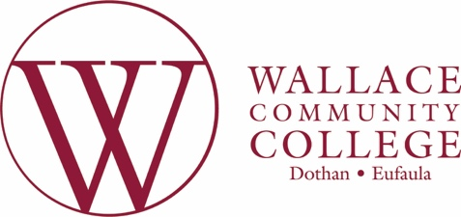
July 28, 2025

MEDIA CONTACT:
Taylor Wheeler
Director, PR & Marketing
twheeler@wallace.edu
O: 334-556-2387

WCCD Sparks Foundation Receives $5,000 Donation for New F.C. Britt Scholarship Fund

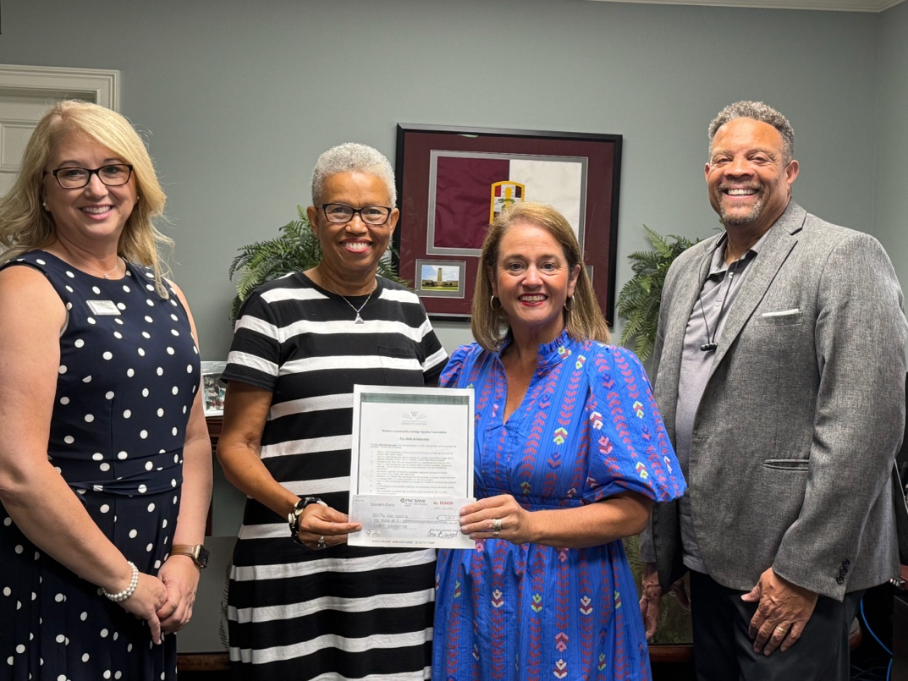

Pictured l to r: Ms. Melissa Mason, WCC Foundations Assistant Director; Ms. Jeanetta Britt, Twelve Stones CDC; Ms. Amy Rasberry, Sparks Foundation Liaison; and Mr. Mickey Baker, WCC Dean, Student Success and Sparks Campus. Not pictured: donor Barbara Cogar.
EUFAULA, AL – The Wallace Community College Sparks Foundation is proud to announce the creation of the F. C. Britt Scholarship, a new scholarship fund established to support Barbour County High School students. This scholarship was made possible through a generous $5,000 donation presented by Barbour County Training School graduates Jeanetta Britt (Class of 1967) and Barbara Cogar (Class of 1962).
The F. C. Britt Scholarship will be available through the Sparks Foundation beginning Fall 2025 for Barbour County High School graduates who attend Wallace Community College full-time. These scholarships are designed to help local students pursue higher education and achieve their academic and career goals.
This new scholarship effort has been made possible through the ongoing generosity of donors giving tax-deductible contributions via Twelve Stones CDC and through dedicated community fundraising led by Mrs. Cogar in her Oakland, California, community.
“I’m delighted to give back to my hometown that gave so much to me,” said Ms. Cogar. “We are grateful to all of our alumni and donors who have made this new scholarship possible,” added Ms. Britt. “We encourage everyone to continue to dig deep and give so these scholarships remain available to support the success of our aspiring students from Barbour County High School.”
“Establishing this new scholarship marks an exciting time in our mission—opening doors, sparking dreams, and empowering the next generation of changemakers through the power of education,” said Ms. Amy Rasberry, WCC Sparks Foundation Liaison. “We are deeply grateful for the generosity of local community members like Ms. Britt and Ms. Cogar who invest in the success of our students.”
The Sparks Foundation works in partnership with the College to ensure access to education and to help achieve success for its students. Scholarships are awarded annually to deserving Sparks students who would not otherwise be able to attend college.
Students interested in applying for the F. C. Britt Scholarship may visit give.wallace.edu or contact Sparks Foundation Liaison Amy Rasberry at (334) 687-3543 x 4234 or arasberry@wallace.edu for more information.
To make a tax-deductible donation to sustain this scholarship fund, visit give.wallace.edu and select the “Sparks” tab.
###

Wallace Community College–Dothan is a member of the Alabama Community College System, which is the state’s single largest system of public higher education. With campuses in Dothan and Eufaula, Wallace offers academic, health and career technical programs, adult education, workforce development training and continuing education, as well as dual enrollment courses for area high school students. Founded in 1949, WCCD celebrated its 75th anniversary in 2024.

